# DIS-AM,C- Maya Jaguar Alabaster Mortar and Lily Pestle-Final

Alabaster, 2.7/8 in. x 1.3/8 in. x 1.1/4 in.

### This mortar has a jaguar bust at one end and a toad at the other end. The Lily-topped pestle is used to grind a compound in the mortar. Around the sides of the mortar are engraved leaves of a plant. Around the rim of the mortar are jaguar paw prints suggesting that the jaguar invites the participant to follow him.

### 

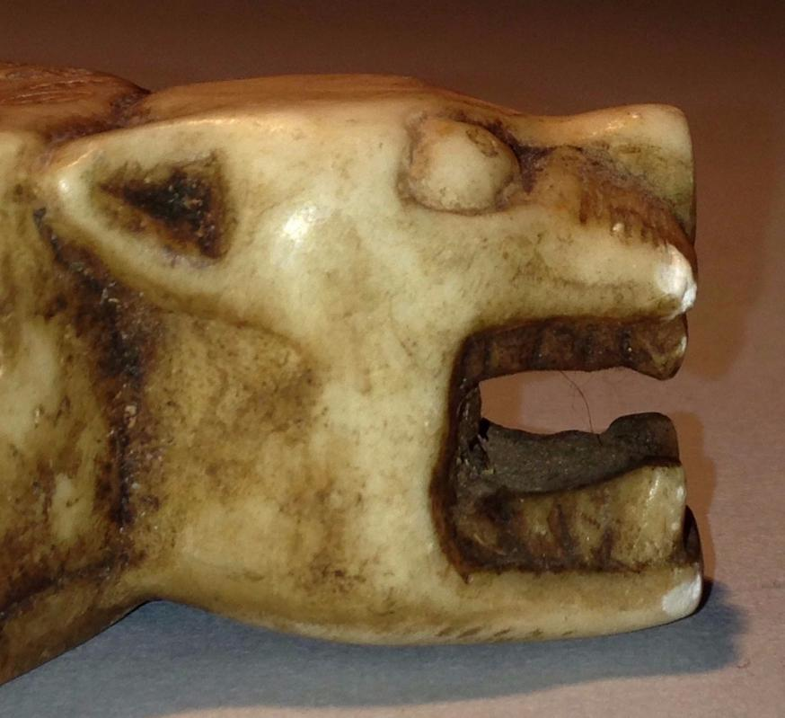 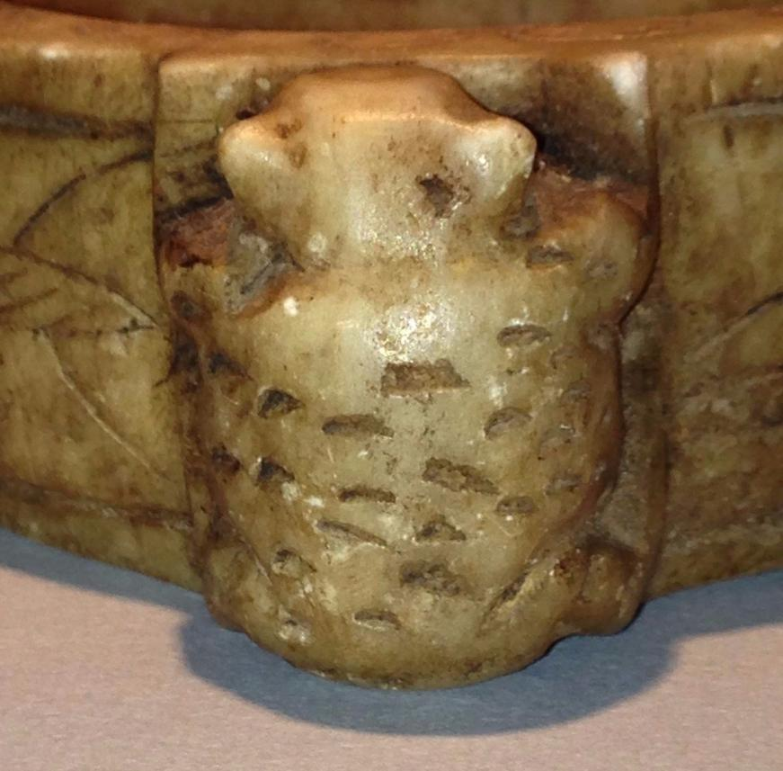 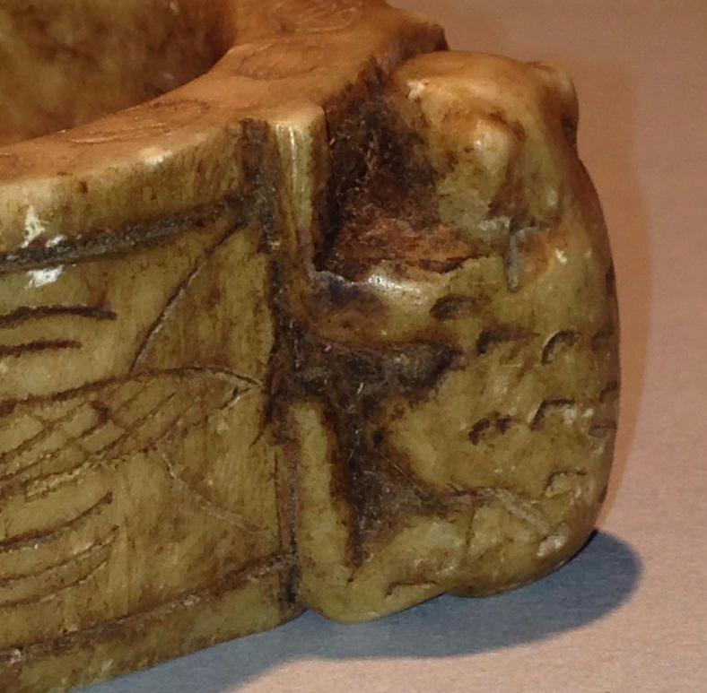

The panels on the perimeter of the mortar (four on the left and three on the right) tell a story.

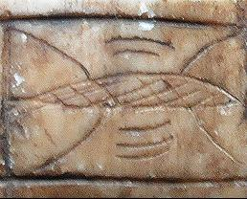

1R

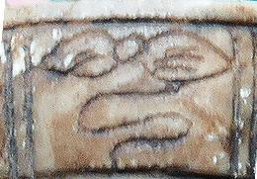

2R

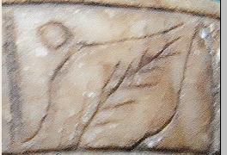

3R

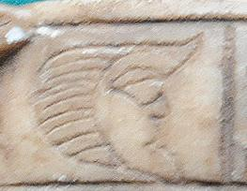

4R

***Lophophora williamsii*** or **peyote** is a small, spineless cactus with psychoactive alkaloids, particularly mescaline. Fr. Bernardino de Sahagun first described the plant in 1560 when he referred to the use of the root "peiotl" by the Chichimeca Indians of Mexico.[[14](https://www.erowid.org/plants/peyote/peyote_info1.shtml" \l "14)

The English common name *peyote* comes from the Nahuatl ***peyōtl***, which is related to **peyōni** "to glisten" according to Andrews (2003).

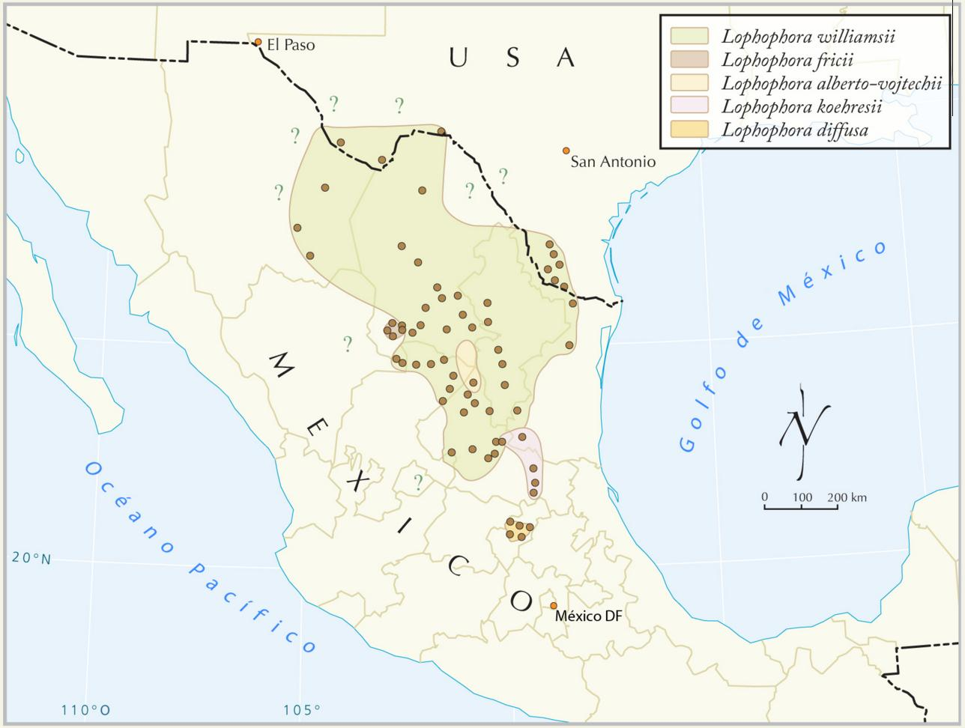

Figure. Distribution of five wild peyote species (genus *Lophophora*) in the Chihuahuan Desert. Map from Terry 2008.

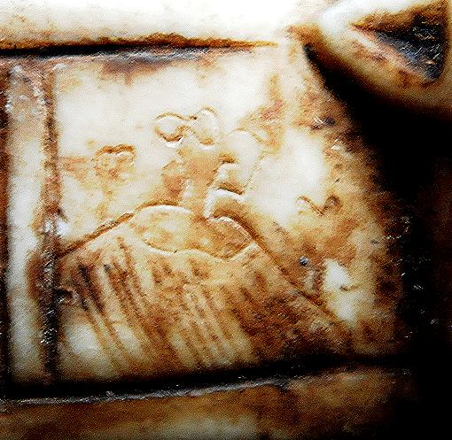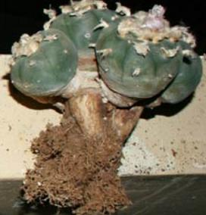

1L. Stylized depiction of  *Lophophora* plant 179 mm at 132 months growing on a mound. Photo from http://www.kadasgarden.com/images/Lophophora-williamsii62.jpg.

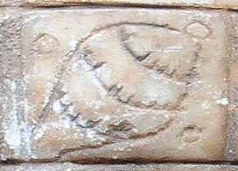

2L. A depiction of a *Lophophora*  in bloom.

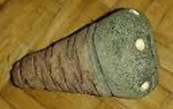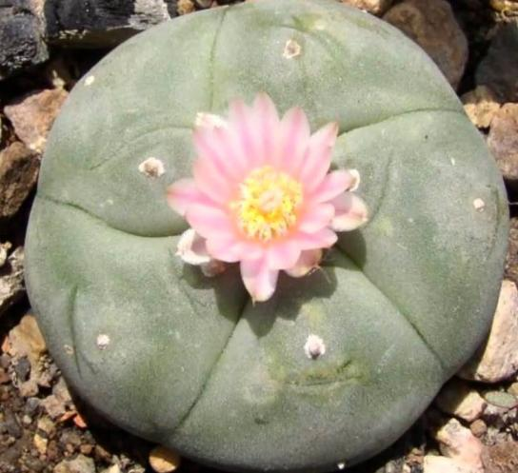 58 mm at 58 months

[Lophophora williamsii](https://www.youtube.com/watch?v=UAQXqZIhsJk).

***Lophophora williamsii*** or **peyote** is a small, spineless cactus with psychoactive alkaloids, particularly mescaline. Fr. Bernardino de Sahagun first described the plant in 1560 when he referred to the use of the root "peiotl" by the Chichimeca Indians of Mexico.[ (Sahagun 1890-1896.).

The English common name *peyote* comes from the Nahuatl ***peyōtl***, which is related to **peyōni** "to glisten" according to Andrews (2003).

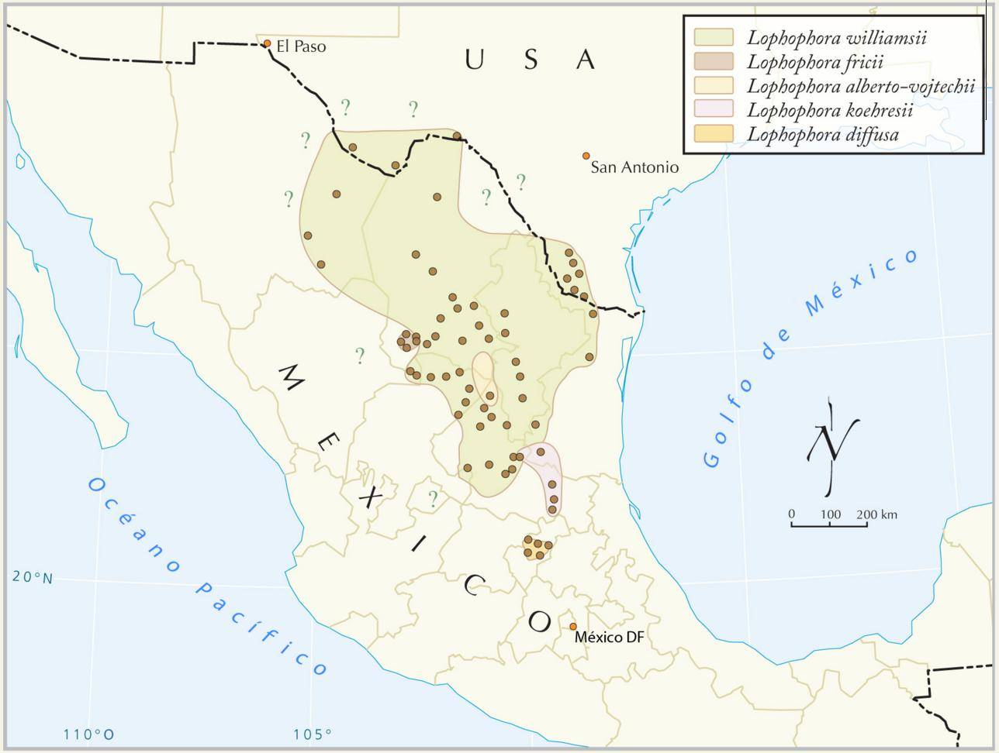

#### Figure. Distribution of five wild peyote species (genus *Lophophora*) in the Chihuahuan Desert. Map from Terry 2008.

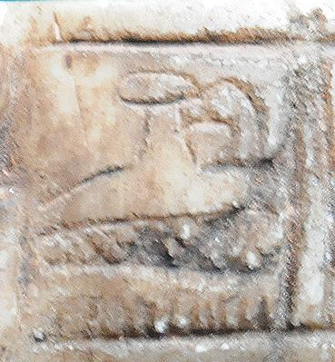

3L. Depiction of hand grasping a button of *Lophophora.*

resemble those of the ayahuasca plant and the five lily petals on the top of the pestle resemble those of the datura lily. The toad suggests that the hallucinogenic poison from the toad’s glands is used to produce a mind-altering preparation. Mayan shamans regularly used hallucinogenic compounds to induce a were-jaguar transformative process in the participant. The Water-Lily is probably the Ayahuasca plant with white lily-like flowers used to make a hallucinogenic concoction. This mortar and pestle were possibly used in the late Classic period as an essential component of a Mayan shaman’s toolkit.

Jaguar deities in pre-Columbian Mesoamerican societies are based on the physical and attributes of (*Panthera onca*) the largest, most agile and one of the most aggressive of the big cats in the Americas, a predator that is the model for swift action, whether on the battlefield, in the act of hunting prey or in the shamanic act of anthropomorphic transformation into the *spiritual* shape of a jaguar.

A clue to the ceremonial in which the mortar and pestle were used may be found on a Late Classic cylindrical, polychrome terracotta vessel on which God A, Water-Lily Jaguar God and Howler Monkey are portrayed in procession. God A is preceded by the "Stone-in-Hand" glyph 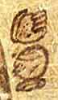, that suggests the event th\ey are about to be involved in involves a stone in the hand. If the “stone” were a pestle, the event may be the preparation of a hallucinogenic concoction. To support this hypothesis, God A is carrying an *akbal olla* or pot suggesting that he is carrying the concoction to the scene of ingestion of its contents. Both the jaguar and the monkey are anthropomorphs with jaguar and monkey apparel, such as jaguar and monkey gloves and shoes. In other words they are already prepared for their spiritual transformations.

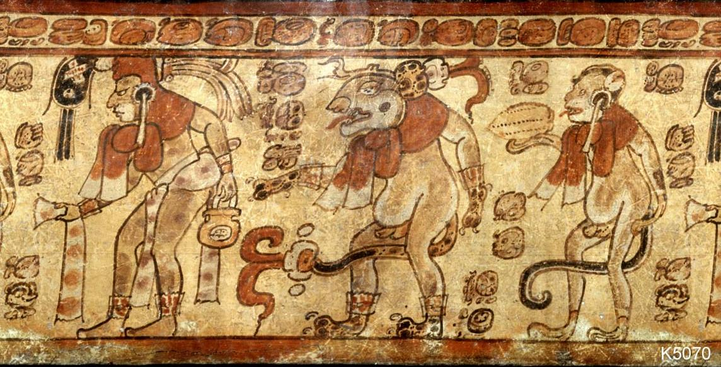

God A, anthropomorphic so-called Water-Lily Jaguar God and anthropomorphic Howler Monkey on a cylindrical, polychrome terracotta vessel. From Kerr (2000), p.919, no. 5070. God A holds an *akbal olla* and precedes the Water-lily Jaguar and a Howler Monkey who is holding a cacao pod.

References

Andrews, J. Richard. 2003. *Workbook for Introduction to Classical Nahuatl, Rev. Ed.*, Tulsa: University of Oklahoma Press, p. 246

Finamore, David, and Stephen Houston (eds.). 2010. *The Fiery Pool*. New Haven: Peabody Essex Museum in association with Yale University Press.

Houston**,** Stephen D. 1998. *Function and meaning in classic Maya architecture : a symposium at Dumbarton Oaks, 7th and 8th October 1994***.** Washington, D.C.: Dumbarton Oaks Research Library and Collection.

Kerr, Justin and Barbara Kerr. 2000. *The Maya vase book : a corpus of rollout photographs of Maya vases. Vol. 6.*  New York, N.Y.: Kerr.

Historia General de las Cosas de Nueva Espana. 10 vols. Mexico: Paz. X, p. 118.

Stuart, David . 1998. “The Fire Enters His House: Architecture and Ritual in Classic Maya Texts”, in Houston, (1998): 373-425.

Taube, Karl . 1992. *The Major Gods of Ancient Yucatan*. Washington, D.C.: Dumbarton Oaks, 1992.

Terry, M. 2008. "Stalking the wild Lophophora: Part 3 San Luis Potosí (central), Querétaro, and Mexico City." Cactus and Succulent Journal 80(6): 310-317

Were-jaguar attributes -- curling lips and hints of fangs -- have been expertly rendered in male child-like figurines to evoke an exceptional jaguar presence.

The Jaguar God of Terrestrial Fire is recognizable by a '[cruller](https://en.wikipedia.org/wiki/Cruller)' around the eyes (making a loop over the nose), jaguar ears, and jaguar fangs. He personifies the number Seven, which is associated with the day *Ak'b'al*[ ('Night'). Usually called 'Jaguar God of the Underworld', he has been assumed to be the 'Night Sun' - the shape supposedly taken by the sun ([Kinich Ahau](https://en.wikipedia.org/wiki/Kinich_Ahau)) during his nightly journey through the underworld - for reason of having the large eyes and filed incisor that also occur with the sun deity, and of sometimes evincing a *k 'in*infix. The deity's hypothetical aspect of a nocturnal sun (that is, a subterranean fire) should perhaps be connected to his proven association with terrestrial fire.

(while his 'cruller' may represent a cord used in making fire with a stick (Taube 1992). Moreover, vases in [codical](https://en.wikipedia.org/w/index.php?title=Codical&action=edit&redlink=1) style show him, captured, about to be burnt with torches. The nocturnal sun hypothesis is complicated by this very incident, and even more so by the fact that the fiery jaguar deity is identified with a star (or, perhaps, a constellation or planet) (Finamore and Houton 2010). The god's other sphere of influence is war, witness for example the stereotypical presence of his face on war shields.

God A, anthropomorphic Water-Lily Jaguar God and anthropomorphic Howler Monkey on a cylindrical, polychrome terracotta vessel. From Kerr, p.919, no. 5070. God A holds an akbal olla and precedes the Water-lily Jaguar and a Howler Monkey who is holding a cacao pod.

The that precedes God A in the rollout image of the Late Classic vessel above suggests grasping something by hand. To take the pestle in hand in this rare example of a Mayan shaman’s toolkit identifies the user as the Water-lily were-jaguar shaman.

Were-jaguar attributes -- curling lips and hints of fangs -- have been expertly rendered in male child-like figurines to evoke an exceptional jaguar presence. The image of a baby suggests a stage of early spiritual development into the features of the Jaguar God of Terrestrial Fire. The Jaguar God of Terrestrial Fire is often represented on incense burners such as this one and is connected to fire rituals,(Stuart 1998).

• Murdy, Carson N. 1981. "Congenital Deformities and the Olmec Were-Jaguar Motif", *American Antiquity* 46(4): 861-871.